 Pangani Basin Water Board 
Hydrological Bulletin October 2025
2025

RAINFALL TRENDS
Generally, In October 2025, the Zigi basin experienced predominantly normal weather conditions, with total rainfall ranging between 32-72mm at a few selected monitoring rainfall stations in Zigi catchment. The average rainfall in this month 27.69mm less than Long Term Average of 33mm.
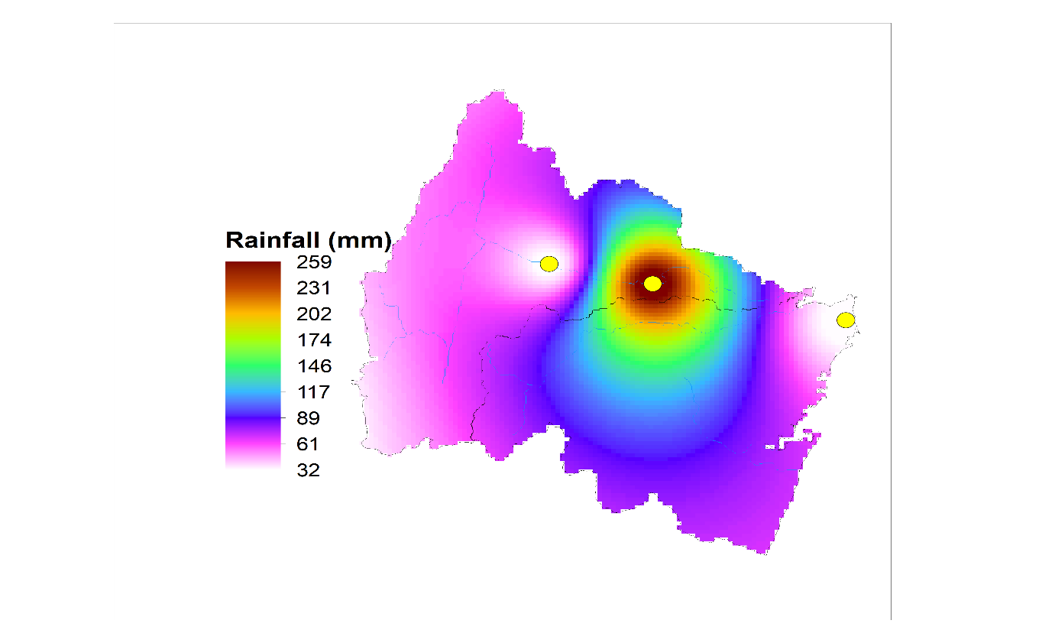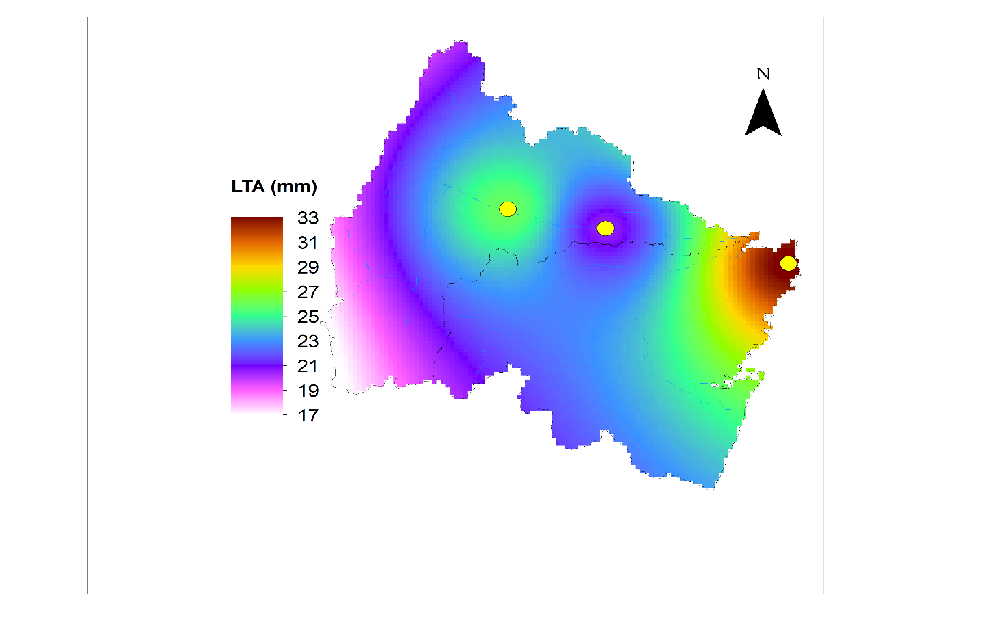

Representative Rainfall stations

Mabayani Dam
Zigi River is the main source of Mabayani Dam which originates from Usambara Mountain and supply water to Tanga City and nearby areas. It is managed by Tanga Urban Water Supply and Sanitation Authority and has storage capacity of 7.7 Mm³ (of which live storage is 5.3 Mm³). Water level trend (water levels fluctuation) for year 2024 and 2025 in 10 months. This situation caused by little rainfall (VULI) received in Zigi catchment.
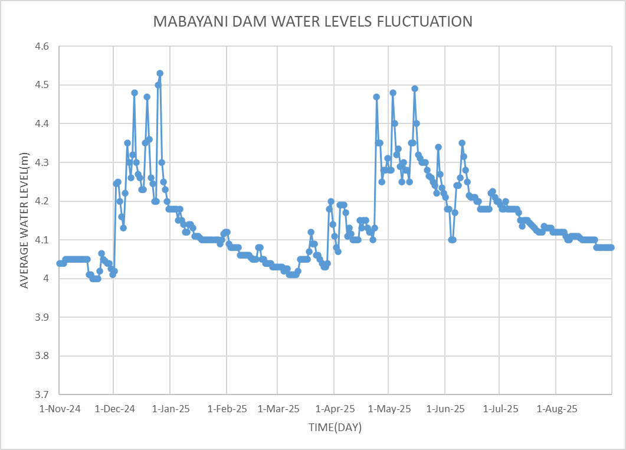

RIVER FLOWS
Zigi River has two major contributing sources which are Muzi River and Kihuhwi River. There are five river gauging stations installed in the catchment. The average flow of the main Zigi River is 2m³/sec. The average flow of Kihuhwi River is 0.4m³/sec and Muzi River is 0.8m³/sec. The flow reaching Mabayani Dam currently is an average of 2.3m³/sec. The figure below shows the flow variation five river gauging stations in the Zigi catchment during October.

CONCLUSION
The Zigi Catchment experience partial distribution of rainfall in this month of October.The catchment surface runoff as well as water levels of Mabayani Dam are expected to be higher than their monthly average in the coming rainfall season.
Therefore, Management of Pangani Basin Water Board emphasizes on effective and efficient use of available water for sustainable water resources management

